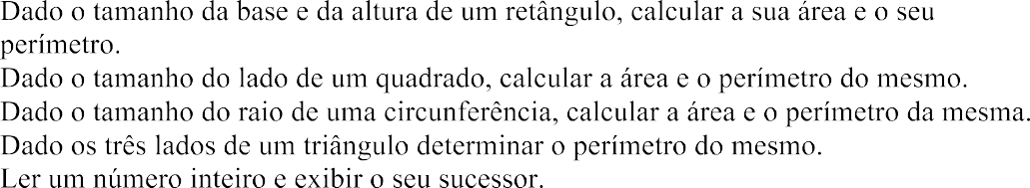 

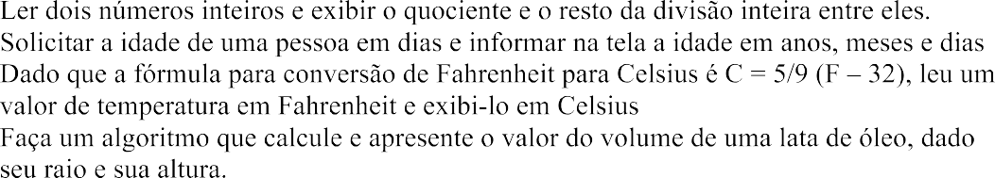

Construa os algoritmos e a programação em python



            
            
            
            
            



